How to configure Aws to data dog,

Datadog home page,
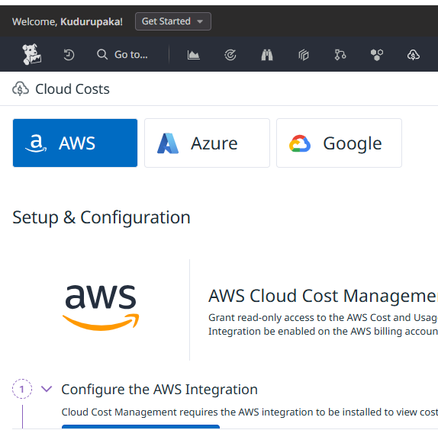

Click on configuration aws integration,
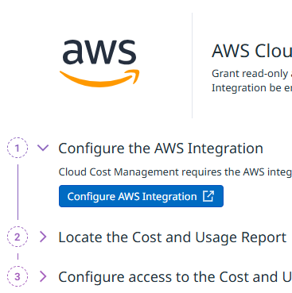

Add Aws new account,
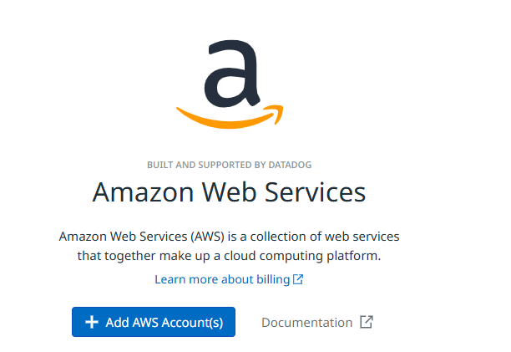

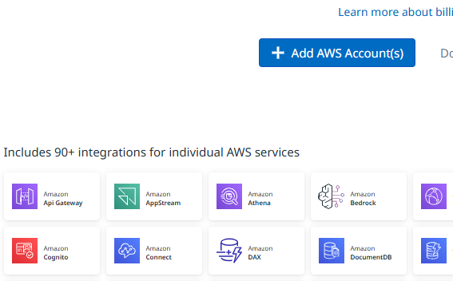

After clicking here we can see two options one is add a single aws account and add multiple accounts,
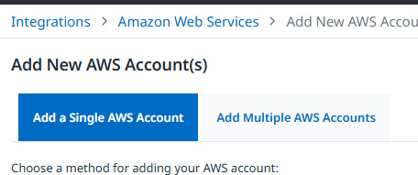

Add a single aws account,
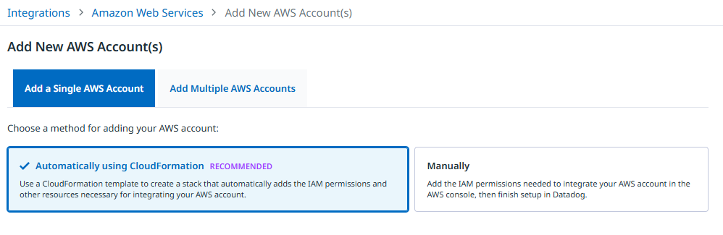

Select add multiple option,
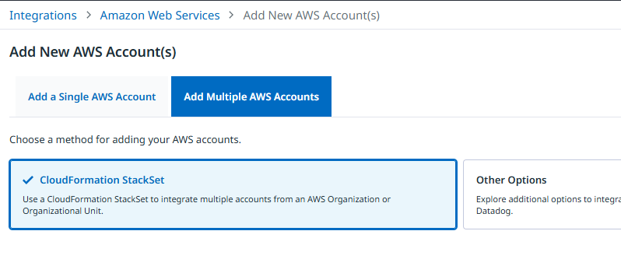

https://datadog-cloudformation-template.s3.amazonaws.com/aws/v2.1.9/main_organizations.yaml
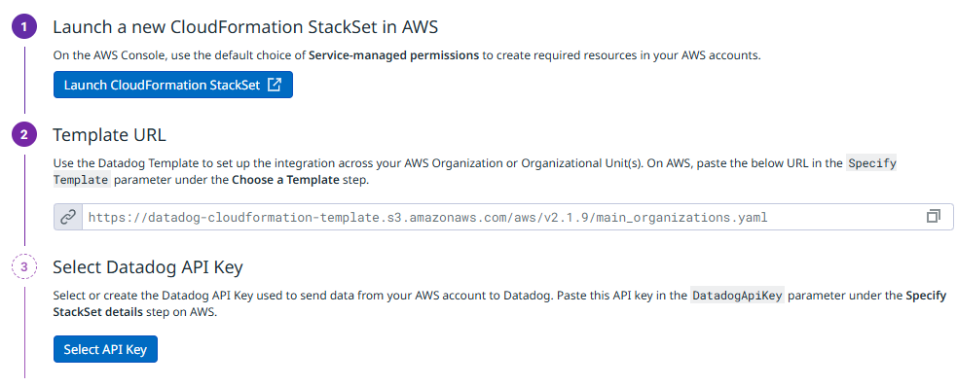

1debf9f2c4f98b4e65e6930237b73b481551b062
